Fixing octrees
10/10/2026
// TO DO: I need to modify the events to run for all kinds of states.
// E.g. once I make a 3D pathfinding system, I want to use the empty octants as the nodes, not the full ones.
// Or maybe I should change 'empty' and 'full' to something like 'invalid' and 'valid'?
// Done!

// It seems that all of the octants are emptied properly if they meet the requirements.
// Are there some that are being ignored? E.g. scrolled past?

// TO CHECK: if I invoke MoveNext() before referencing the current value, does that mean the first value is always skipped?
// Alright I did a test. No it doesn't. In fact I need to invoke MoveNext() at least once before the first variable can be accessed, otherwise I get an InvalidOperationException.

// There's got to be some issue where octants that need to be emptied are being skipped past.
// OR! What if when volumes are being created, duplicates are being made?
// E.g. there's already one present but it makes another anyway?
// No, that shouldn't be an issue.

// Should I modify the delegate to return a value, and ensure it's applied, all in one function?
// Maybe that will help ensure the values are specified? Instead of turning leafData into 'default', it turns it into whatever the null value needs to be?
// Dunno if that'll help but it might be good design anyway.

// Nope it didn't help.

// What if some volumes are somehow being dismissed and re-summoned, or vice versa, on the same frame?
// So one operation overrides the other?
// I noticed several volumes weren't being disabled.
// I modified the code so when they're summoned, they're parented to the SmokeNavMeshModifier rather than staying in their object pool.
// I tested again.
// Nope, the leftover active ones are still parented to the SmokeNavMeshModifier.

// Maybe I can rename the active volumes to tell us info about the octants they're a part of.
// Alright now each octant, when created, tells us what their octant key and type are.
// No common data found in regards to key or type.
// Time to check if that data changes over time.
// I added a second debug message so if a volume has already been created its name is changed to say 'existing' instead of 'new'.
// Testing
// Almost all volumes are 'existing', except for one 'new'

// TO DO: check all cells that say they're invalid but have data assigned.
// Check for each of them what the value is before and after they're iterated through.
// Odd, it seems the leaf data is always perceived as null.

Hang on, here it says the leaf is emptying itself!
Oh duh, that would be because of a FullyValid octant, clearing child cells without deleting them.

Hang on, should I even bother deleting child cells?
Hang on, yes, duh! Them being deleted is how the code knows there’s no old data to check through and delete.

Maybe I can ensure if the ‘delete volume’ code is being run, by having it change its name.
Alright yeah, all the dismissed ones now have their name changed. But the non-dismissed ones don’t. So the code just isn’t being run.

I noticed that the deleted ones are all invalid or branch octants, which makes sense. But there are existing volumes from ‘leaf’ and ‘fully valid’ nodes. These should be dismissed if a parent octant is empty. Since there is no smoke left in the level, and therefore absolutely no populated child octants, all these should have been deleted by default.
I think that EmptyIterator() isn’t working correctly when it comes to iterating through child nodes.
Not sure how though.
WAIT!
‘deleteChildren’ implies emptying the children first.
What if somehow the function is being run with ‘deleteChildren’ being true but not ‘emptyChildren’?
I modified the if statement to run if emptyChildren OR deleteChildren are true.
Let’s see what that does.
Nope, didn’t help.

What was the thing I was thinking of before I thought of that last thing?
Can’t remember, but I just saw a thing showing that enumerators can be disposed of.
I just added code after each IEnumerator is created and iterated through, to run Dispose() and dispose of it properly. Let’s see how that changes things.
Nope, didn’t help.

I still need to focus on how stuff can be marked as Leaf or FullyValid despite there being no particles to check. Either that or they’re children of invalid nodes, that are supposed to be cleared along with their invalid parents.
So when nothing is found that meets the criteria, the Scan() function correctly gets this, as when there’s no smoke the octree is just one giant cube with no subdivisions.
I did some testing and I know that invalid octants are marked for emptying, with all values set to true.
What if it’s something to do with it being an IEnumerator?
Modified the child EmptyIterator() to not yield and just continue, but that didn’t help.
What if I just restarted the editor, and forced a massive recompile?
Nope.
Doing more debug messages.
What if I retried the code that does everything in one frame?
Alright I retried that, and it all seems to be deleted properly.
Scanning and processing everything via Octree.Refresh() seems to work perfectly! Even though it processes everything by running ProcessAllCells(), which runs the same iterator but all at once.
What if the last few cells are being cut off somehow? E.g. the count per frame is wrong and it doesn’t get to refresh everything before the octree is scanned again and everything restarts?
Let’s try running the async method, but with the time multiplier set to zero.
Volumes aren’t all deleted.
Let’s set it to 0.1.
Still volumes present.

I should check how many octants are iterated through and refreshed properly.

A-ha! It shows where the last refresh is before all the child cells are deleted! But for some reason it only cycles through one cell and doesn’t refresh the rest.

Let’s put a debug whenever the refreshes finish, showing the number of cells refreshed compared to the number found.
It seems that when the number of cells shrink, the total number of cells is always the previous time’s ‘cellsRefreshed’. Unusual.
I noticed the iterator for counting the cells is a generic IEnumerator without a type, and there’s no code for disposing of it. It doesn’t seem to be present on the generic types.
What if I changed that to have a proper type, and ran Dispose() at the end of it?
Nope, no difference.
What if Dispose(), or the type being non-generic, is the thing causing it?

Let’s try the totally synchronous one-frame method, but with octree.ProcessAllCells() using a non-generic type and Dispose() at the end?
Nope, the synchronous method still works fine.

The iterators with false and true values should return the same, surely? Since they’re both using the same logic to iterate through the same set of values, but only one is doing anything to them.
I think that somehow, running the events is somehow causing certain values to be skipped.

What if I run the synchronous version, but still count up those values?
I modified ProcessAllCells() (the one that does everything at once), but added another enumerator before that doesn’t alter anything, and merely counts the values. (So false, then true.) Same result!
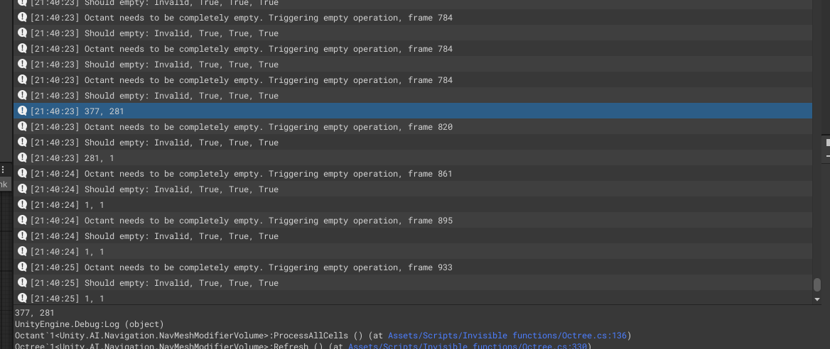
What happens if I have a third one afterwards? (false, true, false)
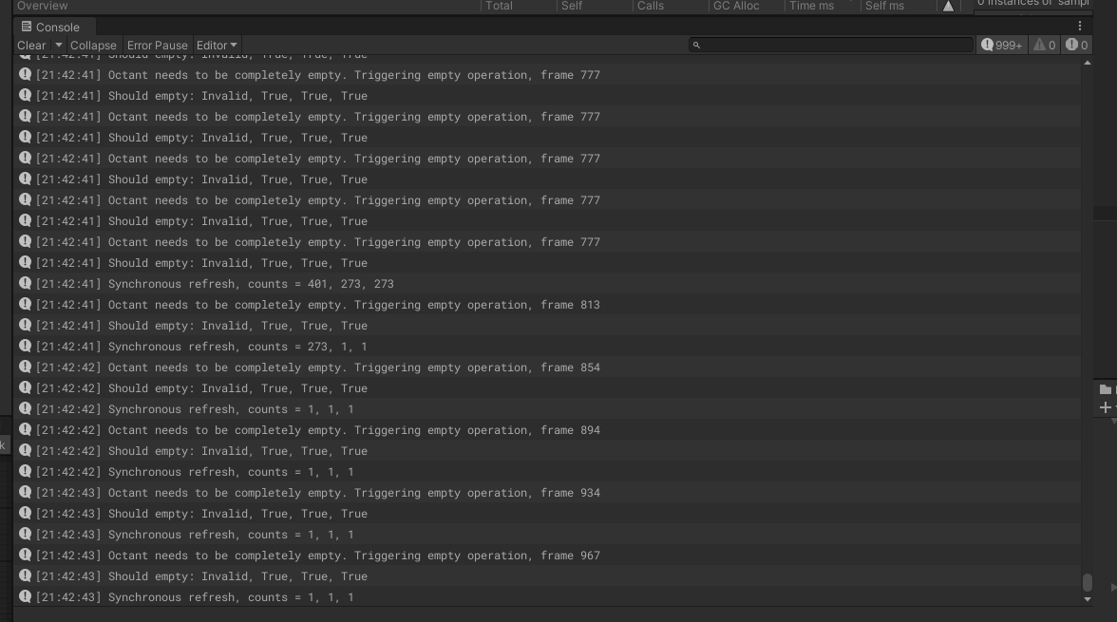
The final one doesn’t alter the value.
What happens if I do (false, true, true)?
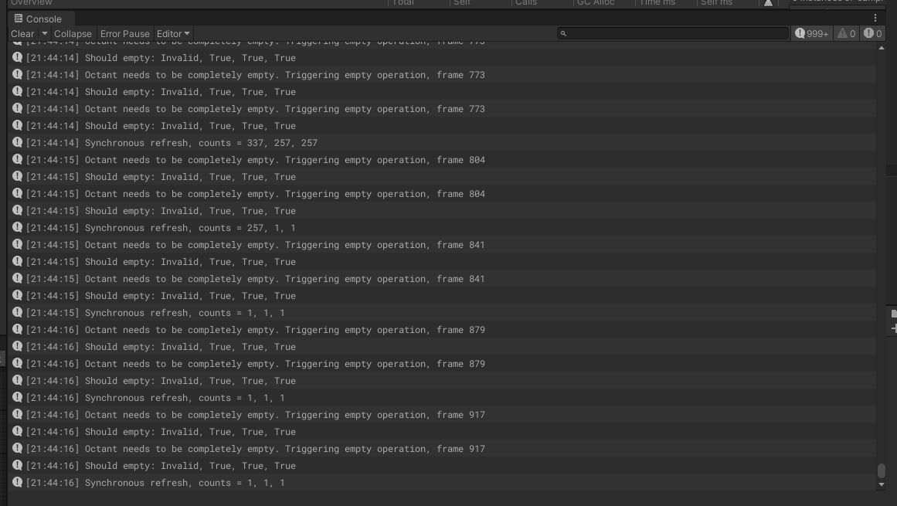
Alright same as before, even though the same if statements should be running.
Hang on, I realised that some of the volumes aren’t being deleted now!
Trying again with just one iteration (neither of the debug ones), it runs fine.
Trying again with just the before debug and the main one, but not the after debug. False!
Alright, so I think the real issue is somehow related to running multiple enumerators from the same octree, between scans.
What if it’s false vs. true? What happens if I run two true ones?
Interesting. When running two iterators both set to process data, everything is deleted properly.
So somehow the non-processing iterator triggers some kind of change, that messes things up for the second one.
Hang on! I realised that the child cells are being deleted, even if ‘processCells’ is false!
Modified the statement to be if (processCells && deleteChildren), instead of just the latter.
It works with the synchronous method! Let’s try the async version.
It deletes everything!
I think I’ve done it! Time to clean everything up, and get back to the actual issue of the refresh still causing spikes even though it’s meant to be spread out over many frames.

I’ve noticed now that the number of iterations is much higher than the actual number of cells.
Ah turns out I forgot to re-enable the code resetting the values.

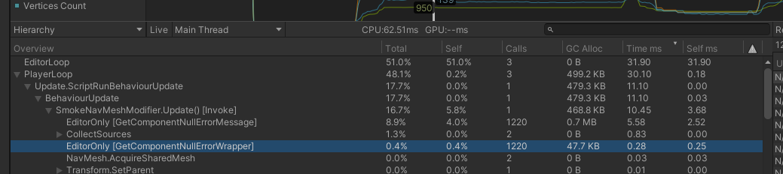It seems that the main cause of the lag spikes are these editor functions.
For some reason it’s always 1220 of them.
Is it related to updating the NavMesh? I tried selecting all the colliders in the scene (Rooftop Descent), and that gave me 1234 results. Only 14 more than the 1220 value.
I modified the NavMesh detection to ignore world-space UI (I don’t know why that was there in the first place), and it reduced the value to 1216.

I think there’s just a stupid amount of colliders.
I wonder if there’s an easy utility to combine multiple primitive colliders into single mesh colliders?

